Assignment 3

Part 2: Data Manipulation with Apache Pig (5%)1. Data Loading (1%)• Load the dataset into a Pig relation with appropriate data types foreach column.





2. Data Filtering (1%)• Split data into tracks with a track popularity less than 50(low popularity) and equal or greater than 50 (high_popularity).



3. Data Grouping and Aggregation (2%)• Group the data by playlist_genre and calculate the average_danceability, tempo, and loudness for each genre.



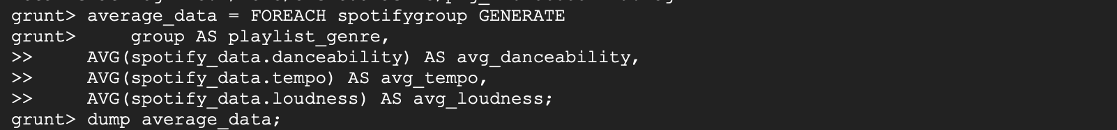

4. Data Exporting (1%)• Store the results of the aggregations into files for further analysis or visualization



